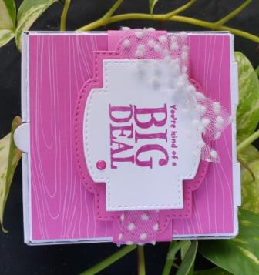
Color Crazy Club
October 2020

You’re a Big Deal!
Step 1:  - Fold Mini Pizza Box – shiny side on the inside  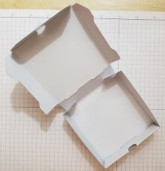 | Step 2:  - Adhere DSP to top and sides of pizza box using liquid glue.  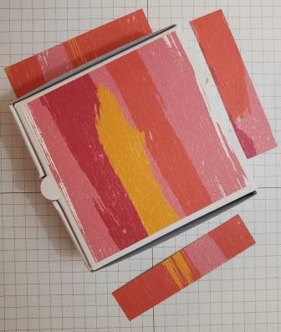
Step 3:  - Wrap 1” stripe around the box using fingers to gently crease the band.  - Using Tear Tape of Stampin’ Seal Plus glue ends together with the join on TOP of the box  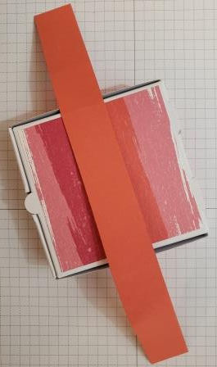 | Step 4:  - Die cut large label from Stitched So Sweetly dies  - Adhere the label to the band using Tear Tape of Stampin’ Seal Plus  - Wrap Polka Dot Tulle ribbon around and glue down top of the label  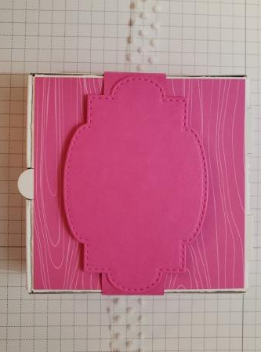

Step 5:  - Die cut second largest label from the Stitched So Sweetly dies  - Stamp label with sentiment from Whale Done  - Place on top of ribbon using dimensionals  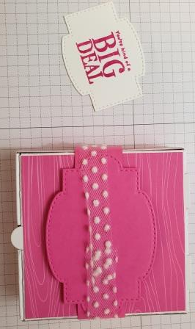 | Step 6:  - Tie a small bow and adhere with glue dot to top left corner of label.  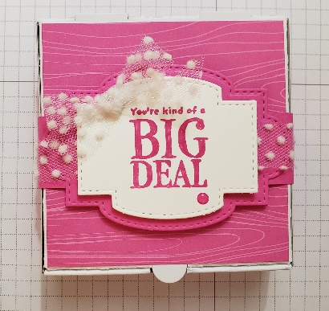  - Embellish with a Magenta Madness In-Color Enamel dot

Tailored Tags Card Recipe
Whale Done stamp set | Magenta Madness DSP:  (4) 3 3/8” x 7/8”  (1) 3 3/8” x 3 3/8”
Mini Pizza Box
Stitched So Sweetly Dies
Magenta Madness Stampin’ Pad | Magenta Madness cardstock 10” x 1”, scrap for label
In-Color Enamel Dots | Polka Dot Tulle 18”
Cut & Emboss Machine | Liquid Glue
Dimensionals
Beth Brach
Independent Stampin’ Up! Demonstrator
Brachfam Cards & Crafts
brachfamcards@gmail.com
https://brachfamcards.stampinup.net
407.552.6600

